Hubert E. Zerkel, Sr.
December 30, 1889 – November 30, 1972

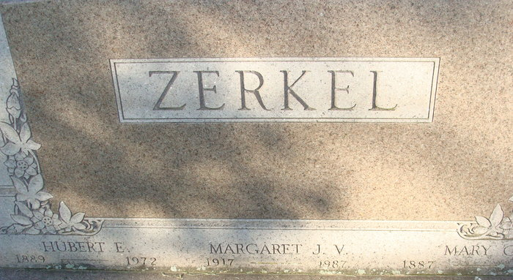
Photo by Alicia Kneuss

HUBERT E. ZERKEL, SR. 82, RETIRED MAIL CARRIER, DIES.

Hubert E. Zerkel, Sr. 82 of 417 North Fifth St. well known retired rural mail carrier, and lifelong resident of Adams County, died at 9:20 p.m. Thursday at the Lutheran Hospital in Fort Wayne, following an extended illness. Mr. Zerkel retired November 30, 1956, after serving for 39 years as a rural mail carried out of the Decatur Post Office. He was born in Kirkland Township December 30, 1889, a son of Jacob A. and Oceana Bell-Zerkel, and was married to Mary G. Shilling, September 1909. His wife preceded him in death May 25, 1968. Mr. Zerkel was a member of the First United Methodist Church, Decatur Lodge 571 and F&AM and the Scottish Rite.
Surviving are two daughters, Mrs. Sylvester (Justine) Everhart of Decatur and Miss Margaret J. Zerkel, at home; one son, Hubert E. Zerkel, Jr. principal of the Bellmont High School; one sister, Mrs. Grace M. Smith of Decatur, route 6; seven grandchildren; and eight great-grandchildren. One son, Wayne S. Zerkel, four sister and three brothers are deceased. Funeral rites will be Sunday at Winteregg-Linn Funeral Home with Rev. Harold L. Leinnge officiating. Burial will be Decatur Cemetery. Friends may call at the funeral home after 7 p.m. today until time of the services. Masonic services will be held at 7:30 p.m. Saturday.
Preferred memorials are to the church building fund or Cancer Society.

Decatur Daily Democrat, Adams County, Indiana
December 1, 1972

