Hubert Zerkel, Jr.
September 12, 1921 – May 23, 2015

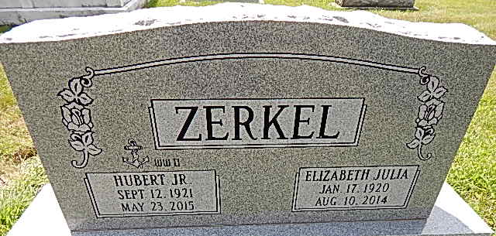
Photo by Alicia Kneuss

Hubert Zerkel Jr., 93, of Wakarusa, IN, formerly of Decatur, IN died on May 23, 2015 at Millers Merry Manor in Wakarusa. Hubert was born on September 12, 1921 in Decatur, IN to the late Hubert E. Zerkel Sr. and Mary (Shilling) Zerkel. On November 24, 1943 he married Elizabeth J. “Betty” Stewart; she preceded him in death on August 10, 2014.
Hubert was a life time active member of the First United Methodist Church. He served his country in the United States Navy during W.W. II. Hubert was a teacher and coach at Kirkland School; teacher and principal at Northwest Elementary; assistant principal and principal at Decatur High School, principal at Bellmont High School and Bellmont Jr. High; he served 17 years as manager of the Decatur City Pool; elected to Decatur City Council for 2 terms and was a substitute rural mail carrier in his retirement.
Herbert was also a member of the Decatur Masonic Lodge F&AM #571, Scottish Rite Valley of Ft. Wayne and former Decatur Rotarian.
He is survived by a son, Alan (Mary) Zerkel of Coatsville, IN; three daughters, Julie (Jim) Werbe of Fishers, IN, Deb (Hal) Martin of Roanoke, IN and Cindy (Mark) Hill of Wakarusa, IN; 12 grandchildren and 30 great grandchildren.
Visitation will be on Friday, May 29, 2015 from 9:00 a.m.-1:00 p.m. at Haggard-Sefton & Hirschy Funeral Home, followed by a 1:00 p.m. Celebration of Life service. Private burial will be in Decatur Cemetery with Military Graveside Rites by American Legion Post 43 Color Guard.
Memorials are to First United Methodist Church.
Haggard & Sefton Funeral Home, Adams County, Indiana
May 24, 2015

