Elizabeth Julia “Betty” (Stewart) Zerkel
January 17, 1920 – August 10, 2014

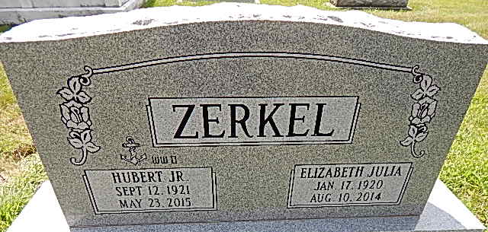
Photo by Alicia Kneuss

Elizabeth J. “Betty” Zerkel, 94 of Wakarusa, IN formerly of Decatur died on Sunday, August 10, 2014 at Miller’s Merry Manor in Wakarusa. Betty was born on January 17, 1920 in Livingston Manor, NY to the late Harry and Pearl (Roosa) Stewart. On November 24, 1943 she married Hubert Zerkel Jr.
Betty was a member of the First United Methodist Church in Decatur. She was head Librarian for 20 years in Decatur. She was also a member of the Eastern Star and Girl Scout Leader.
Betty is survived by her husband, Hubert Zerkel Jr. of Wakarusa, IN; a son, Alan (Mary) Zerkel of Coatsville, IN; three daughters, Julie (Jim) Werbe of Fishers, IN, Deb (Hal) Martin of Roanoke, IN and Cindy (Mark) Hill of Wakarusa, IN; a brother, Harry Stewart Jr. of New Paltz, NY: 12 grandchildren and 25 great grandchildren. She was preceded in death by two sisters and a brother.
Calling will be from 10:00 a.m.-12:00 p.m. Saturday, August 16, 2014 at Haggard-Sefton & Hirschy Funeral Home followed by a 12:00 p.m. Celebration of Life service. Burial will be in Decatur Cemetery.
Memorials are to First United Methodist Church.

Haggard & Sefton Funeral Home, Adams County, Indiana
August 11, 2014

