Ada (Savieo) Zerkel
February 11, 1915 – June 1, 1966

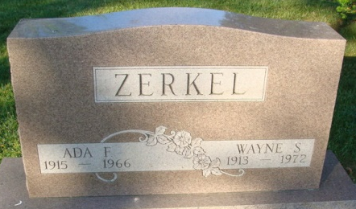
Photo by Alicia Kneuss

MRS. WAYNE ZERKEL DIES SUDDENLY

Mrs. Wayne Zerkel, 51, wife of Wayne Zerkel, of 5839 Radcliff Drive, Fort Wayne, and a former resident of Decatur, died at 11:30 a.m. Wednesday at the Lutheran Hospital in Fort Wayne. She had been critically ill only four hours. Her husband, son of Mr. and Mrs. Hubert Zerkel Sr., of this city, is a production engineer for Central Soya. She was born in Monroeville Feb 11, 1915, a daughter of James and Molly Taylor Savieo, and was married to Wayne Zerkel Aug 6, 1932. The family has lived in Fort Wayne for the past 12 years. Mrs. Zerkel was a member of the Epworth Methodist Church in Fort Wayne, and the Order of Eastern Star in Decatur.
Surviving are her husband; one son Jack Zerkel of Fort Wayne; one grandchild, Mark Zerkel; two brothers Howard Savieo of Fort Wayne, and Owen Savieo of Camp Robinson, Canada; and three sisters, Mrs. Carl (Cara) Shirk of Fort Wayne, Mrs. Harold (Helen) Ervin of Madera, Calif., and Mrs. Joseph (Lena) Bowyer of Monroeville. One son, two brothers and one sister are deceased.
Funeral services will be conducted at 1:30 p.m. Friday at the Zwick Funeral Home, with Rev. Robert L. Carmin officiating. Burial will be in the Decatur Cemetery. Friends may call at the funeral home after 6 p.m. today, until time of service.
The family would prefer memorials to the Epworth Methodist Church building fund.

Journal-Gazette, Allen County, Indiana
June 2, 1966

