Jeffery Allen Zerby
July 20, 1976 – July 20, 1976

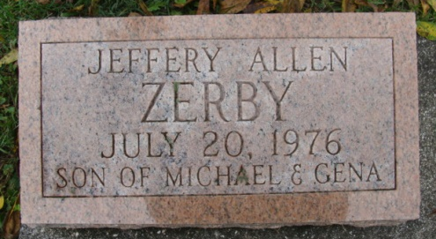
Photo by Alicia Kneuss

Jeffery Alan Zerby
in the Indiana, U.S., Death Certificates, 1899-2017
Name Jeffery Alan Zerby
Gender Male
Marital Status Never Married (Single)
Age 5 hours
Birth Date 20 Jul 1976
Birth Place Indiana
Death Date 20 Jul 1976; premature
Death Place Decatur, Adams, Indiana, USA
Death Registration Date 1976
Father Michael Zerby
Mother Gino Winget
Informant Michael Zerby; father; Berne, Indiana
Burial July 21, 1976; Decatur Cemetery; Decatur, Indiana

