Linda Lou (August) Zemanek
August 16, 1950 -

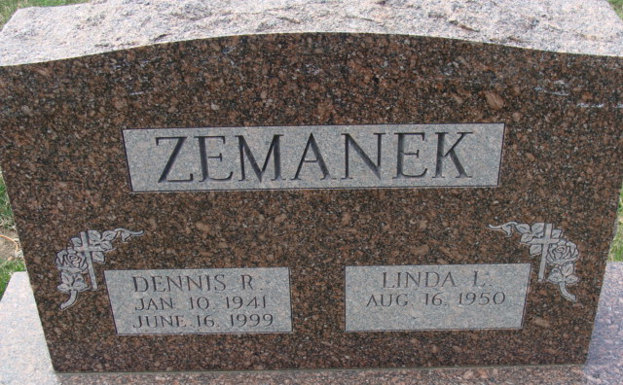
Photo by Alicia Kneuss

Linda Lou August
in the Indiana, U.S., Marriage Certificates, 1960-2012
Name Linda Lou August
Gender Female
Marriage Age 29
Birth Date abt 1951
Birth Place Indiana
Marriage Date 16 Feb 1980
Marriage Place Decatur, Adams, Indiana, USA
Marriage Registration Date 1980
Spouse Dennis Robert Zemanek
Description Adams-St. Joseph
Notes 2 N
Reference Number 1 Bx1449
Reference Number 2 Tr8600
Certificate Number 80-002066

