Dennis R. Zemanek
January 10, 1941 – June 16, 1999

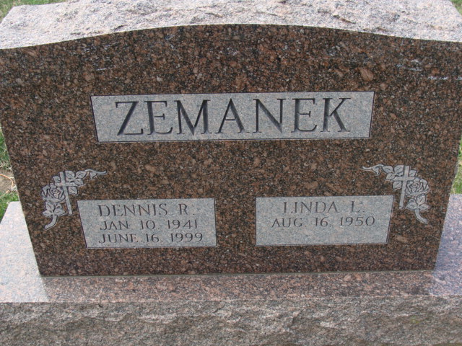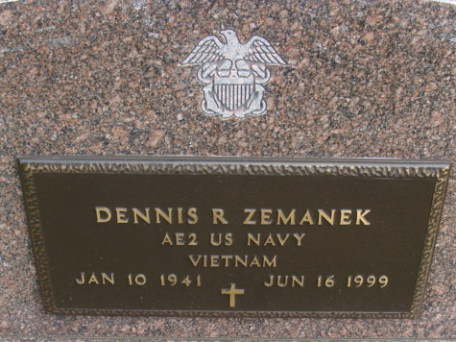
Photo by Alicia Kneuss

Dennis R. Zemanek, 58, of Huntertown, a retired outside plant engineer, died Wednesday, June 16, 1999, at Lutheran Hospital. The Elkhart native retired in 1991 from GTE after 25 years of service; was a member of Our Hope Lutheran Church, American Legion Post 47, Huntertown VFW Post 11314, Indiana Independent Telephone Pioneers, a Vietnam War Navy veteran and enjoyed cooking and woodworking.
Surviving are his wife, Linda A.; a nephew, Kevin L. Zemanek of Kasson, Minn.; and a niece, Karon Ponko of Elkhart.
Services are 1 p.m. Friday at our Hope Lutheran Church, 1826 Trinity Drive, Huntertown, with calling one hour before services. Calling is also from 2 to 4 and 6 to 8 p.m. Thursday at D.O. McComb & Sons Pine Valley Park Funeral Home, 1320 E. Dupont Road. Burial with military graveside services will be in Decatur Cemetery.
Memorials are to the American Cancer Society Greater Fort Wayne Unit or the church.

News-Sentinel, Allen County, Indiana
June 17, 1999

**
Indiana, U.S., Death Certificates, 1899-2017
Name Dennis R Zemanek
Gender Male; Race White
Marital Status Married
Age 58
Birth Date 10 Jan 1941
Birth Place Indiana
Death Date 16 Jun 1999
Death Place Fort Wayne, Allen, Indiana, USA
Father Henry Zemanek
Mother Florence E Clark
Spouse Linda A August
Informant Linda Zemanek; wife; Huntertown, Indiana
Burial June 18, 1999; Decatur Cemetery; Decatur, Indiana

