Emma Marie (Hudson) Zeiler
August 12, 1901 – July 13, 1983

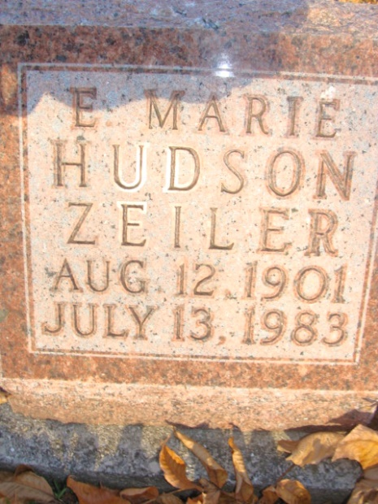
Photo by Alicia Kneuss

Emma Marie Zeiler
in the Indiana, U.S., Death Certificates, 1899-2017
Name Emma Marie Zeiler
[Emma Marie Hudson]
Gender Female
Race White
Marital Status Widowed
Age 81
Birth Date 12 Aug 1901
Birth Place Indiana
Death Date 13 Jul 1983
Death Place Portland, Jay, Indiana, USA
Death Registration Date 1983
Father Albert Hudson
Mother Susan Richardson
Informant None listed
Burial July 15, 1983; Decatur Cemetery; Decatur, Indiana

