Raymond Zehr
May 16, 1903 – May 28, 1961

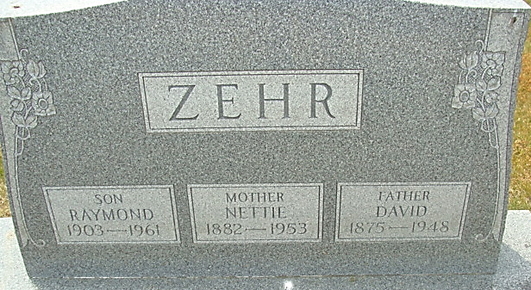
Photo by Alicia Kneuss

Raymond Zehr
in the Indiana, U.S., Death Certificates, 1899-2017
Name Raymond Zehr
Gender Male
Race White
Marital Status Never Married (Single)
Age 58
Birth Date 16 May 1903
Birth Place Indiana
Death Date 28 May 1961
Death Place Decatur, Adams, Indiana, USA
Death Registration Date 1961
Father David Zehr
Mother Nettie Irwin
Informant Manley Irwin; uncle; Decatur, Indiana
Burial May 31, 1961; Decatur Cemetery; Decatur, Indiana

