Nettie (Irwin) Zehr
January 27, 1882 – June 23, 1953

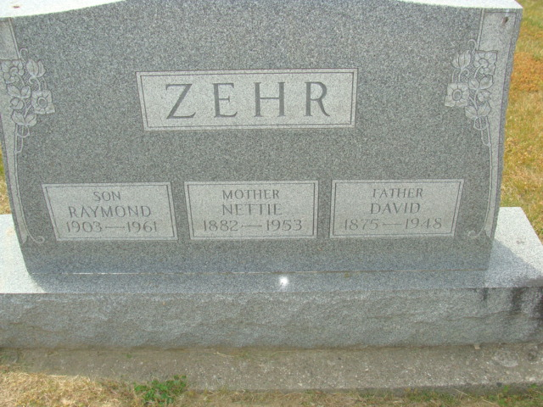
Photo by Alicia Kneuss

MRS. SCHAFFNER'S SISTER SUCCUMBS

Mrs. Nettie Zehr, 71, sister of Mrs. Amiel Schaffner of Kear road, died Tuesday night at her home in Decatur, Ind., after an extended illness.
Rites will be at 2 p.m. Friday at the United Brethren in Christ Church in Decatur and burial will be in Decatur Cemetery.
A son, Raymond Zehr of Decatur, a brother, two sisters and two half-sisters survive.

Van Wert Times Bulletin, Van Wert County, Ohio
June 24, 1953

**
Indiana, U.S., Death Certificates, 1899-2017
Name Nettie Zehr
[Nettie Irwin]
Gender Female
Race White
Age 71
Marital Status Widowed
Birth Date 27 Jan 1882
Birth Place Indiana
Death Date 23 Jun 1953
Death Place Decatur, Adams, Indiana, USA
Death Registration Date 1953
Father: Philip Irwin
Mother: Elisabeth Rutledge
Informant: Raymond Zehr; Decatur, Indiana
Burial: June 26, 1953; Decatur Cemetery; Decatur, Indiana

