David Zehr
May 5, 1875 – March 18, 1948

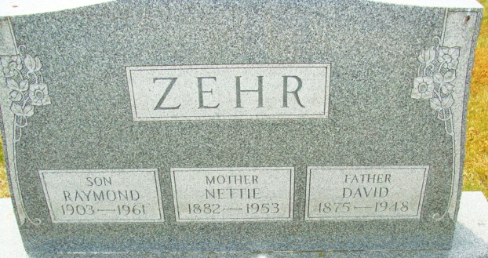
Photo by Alicia Kneuss

DAVID ZEHR, 72, DIES FOLLOWING SHORT ILLNESS
Former Berne Man Succumbs at Hospital; Funeral Sunday

David Zehr, 72, of Decatur, former resident of Berne and a native of the south half of Adams County, died at 2:00 o’clock Thursday afternoon at the Adams County Memorial Hospital. Death was unexpected and came after a short illness. Mr. Zehr was moved to the hospital Thursday noon.
Two doctors, one from Berne and one from Decatur attended Mr. Zehr during his brief illness. They said death was caused by peritonitis from a ruptured appendix. He became ill Wednesday and died less than 24 hours later. An operation was attempted Thursday at the hospital soon after Mr. Zehr was admitted but the operation was not completed because of his grave condition.
Mr. Zehr had lived in Decatur since 1926 when he moved there from Berne. He was a carpenter and had followed that trade for many years. He was born in Geneva May 5, 1875, the son of George and Lydia Roth Zehr. He was married to Nettie Irwin February 3, 1901. Mr. Zehr lived on a farm east of Berne for many years.
Surviving are the widow; a son, Raymond, at home; five brothers, Christian, Berne Route 2; Jacob, Pettisville, Ohio; Amos B., Grabill; Simon, Harlan, and William, Portland, Oregon; a sister, Mrs. Edward Beitler, Linn Grove. Three sisters are deceased.
The body removed to the Zwick Funeral Home, will be returned to the residence at 817 Russel Street at 7:00 p.m. Friday. Funeral services will be conducted Saturday at 12:30 p.m. at the residence and at 1:00 o’clock in the Nuttman Avenue Evangelical United Brethren Church, of which he was a member, with the Rev. C. N. VanGundy and the Rev. Dwight C. McCurdy officiating. Burial will be in Decatur Cemetery.

Adams County Historical Museum, Adams County, Indiana
December 1947 – April 1948 Scrapbook, image 39
Handwritten date: Friday, March 19, 1948

