Richard G. Zander
July 7, 1918 – September 21, 1994

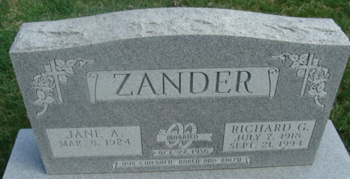
Photo by Alicia Kneuss

Richard G. Zander, 76, of Decatur died yesterday in Lutheran Hospital. The Soldin, Germany, native retired in 1983 from Luginbill Wire Die after 32 years and also from farming.
Surviving are his wife, Jane; a daughter, Jane Zander of Fort Wayne; and a son, Ralph of Decatur.
Services are 10:30 a.m. Saturday in Zwick-Sefton & Jahn Funeral Home, Decatur, and 11 a.m. in Beautiful Savior Lutheran Church, Decatur, with burial in Decatur Cemetery. Calling is 7 to 9 p.m. today, and 2 to 5 and 7 to 9 p.m. tomorrow in the funeral home.
Preferred memorials are gifts to the church.

News-Sentinel, Allen County, Indiana
September 22, 1994

**
Indiana, U.S., Death Certificates, 1899-2017
Name Richard G Zander
Gender Male
Race White
Marital Status Married
Age 76
Birth Date 7 Jul 1918
Birth Place Soldin, Germany
Death Date 21 Sep 1994
Death Place Fort Wayne, Allen, Indiana, USA
Death Registration Date 1994
Father Bart Zander
Mother Augusta Reichert
Spouse Jane Berning
Informant Jane Zander; wife; Decatur, Indiana
Burial September 24, 1994; Decatur Cemetery; Decatur, Indiana

