Jane Ann (Berning) Zander
March 8, 1924 – April 4, 2012

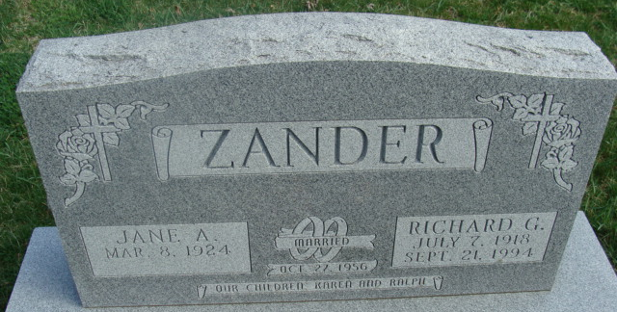
Photo by Alicia Kneuss

Jane Ann Zander, 88 years old of Decatur, Indiana, passed away on Wednesday, April 4, 2012, in Lutheran Life Villages located in Fort Wayne. She was born on Saturday, March 8, 1924 in Fort Wayne, Indiana, the daughter of the late Charles Berning and the late Amanda (Scheumann) Berning. She married Richard G. Zander on October 27, 1957, and he passed away on September 21, 1994. Jane was a member of the Beautiful Savior Lutheran Church in Decatur. She was a homemaker and had worked as a secretary for thirteen years with Phelps Dodge, Indiana Tech & Rea Magnet Wire in Fort Wayne.
Surviving is her son, Ralph Zander of Decatur, Indiana and daughter, Karen Zander of Fort Wayne, Indiana. Preceding Jane in death were two brothers, Ralph & Robert Berning.
Funeral services will be held at 11:00 a.m. Tuesday, April 10, 2012, in the Beautiful Savior Lutheran Church with Rev. Timothy Pederson officiating. Interment will follow in the Decatur Cemetery. Friends will be received from 2 to 4 and 6 to 8 p.m., Monday, April 9 in the Zwick & Jahn Funeral Home, Decatur and one hour prior to the service at the church on Tuesday.
Preferred memorials are to Beautiful Savior Lutheran Church.

Zwick & Jahn Funeral Home, Adams County, Indiana
April 5, 2012

