John Willard Youse
November 12, 1897 – December 20, 1968

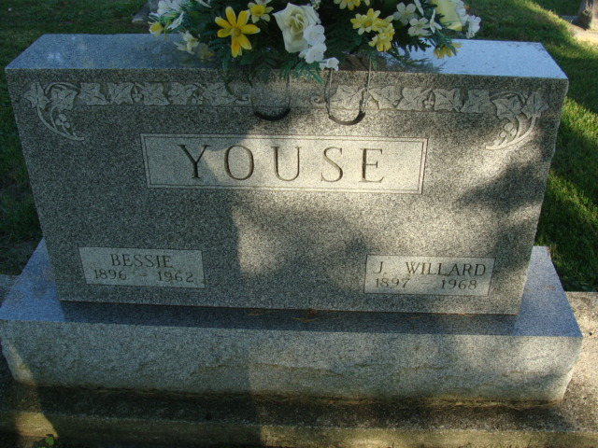
Photo by Alicia Kneuss

Indiana, U.S., Death Certificates, 1899-2017

Name John Willard Youse
Gender Male
Race White
Marital Status Widowed
Age 71
Birth Date 12 Nov 1897
Birth Place Indiana
Death Date 20 Dec 1968
Death Place Fort Wayne, Allen, Indiana, USA
Death Registration Date 1968
Father John S Youse
Mother Sarah Gresley
Informant Hester Dawson, daughter
Burial Decatur Cemetery 12-23-1968

