Bessie (Harrod) Youse
February 4, 1896 – April 25, 1962

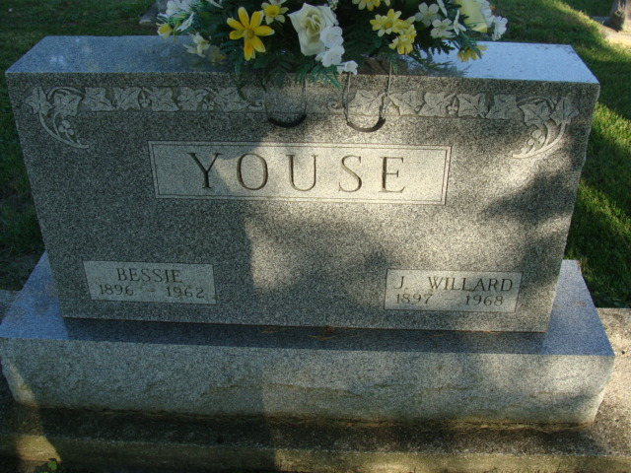
Photo by Alicia Kneuss

Indiana, U.S., Death Certificates, 1899-2017

Name Bessie Youse
[Bessie Harrod]
Gender Female
Race White
Marital Status Married
Age 66
Birth Date 4 Feb 1896
Birth Place Indiana
Death Date 25 Apr 1962
Death Place Fort Wayne, Allen, Indiana, USA
Father Enos Harrod
Mother Hester Harrod
Informant Paul Youse, son
Burial 4-28-1962 Decatur Cemetery

**
Indiana, U.S., Marriages, 1810-2001

Name Bessie Harrod
Gender Female; Race White
Age 25
Birth Date 4 Feb 1896; Birth Place Hoagland, Indiana
Marriage Date 23 Feb 1921; Marriage Place Indiana, United States
Residence Place Hoagland, Allen, Indiana
Father Enice Harrod
Mother Hester Hawke
Spouse John Willard Youse
Page 158; FHL Film Number 002130030

