Romaine Iantha (Raudenbush) Young
June 1, 1919 – July 14, 2006

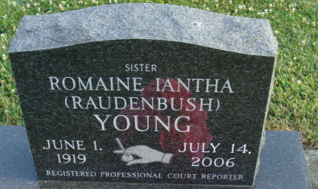
Photo by Alicia Kneuss

Romaine I. Young, 87, of Van Wert, Ohio, died Friday, July 14, 2006 at Hearth & Home, Van Wert. Born June 1, 1919, the daughter of the late Homer I. Raudenbush and Olive L. (Tague) in Adams County. She married Robert Young on Aug, 28, 1958. She was a short hand reporter with Adams County Circuit Court for the late Judges Myles F. Parrish and Robert Anderson. She was a member of National Shorthand Reporter Association, Indiana State Bar Association. She received the Otis Bowen Award Aug. 14, 1980 and the Sagamore of the Wabash from Robert D. Orr Aug. 3, 1984.
Surviving are step-sons, Robert A. Young of Van Wert and John M. Young of Cedar Rapids, Iowa; step-daughter, Nancy Uncapher of Gary; brother, Roscoe G. Raudenbush of Decatur; neices, Diane (Richard) Engle of Decatur and Margy (Basil) Dealcy of Convoy, Ohio; nephews, Kenneth Weaver of Huntertown, Danny Eyanson of Fort Wayne, Larry Raudenbush and Gary Raudenbush, both of Decatur. She was preceded in death by husband, Robert Young on Oct. 28, 1996; step-daughter, Margaret Hughes; sisters, Rowena Philips and Ruth Weaver; brothers, Roger, Bob, and Raymond Raudenbush.
Service is 1:30 Monday at Haggard & Sefton Funeral Home, 225 W. Adams St., Decatur, with The Rev. Jeff Taylor. Visitation is from 2 to 6 p.m. Sunday at the funeral home. Burial in Decatur Cemetery. Memorials to Union Chapel Church.

Journal Gazette, Allen County, Indiana
July 16, 2006

