Mary Margaret Young
February 22, 1920 – July 22, 1920

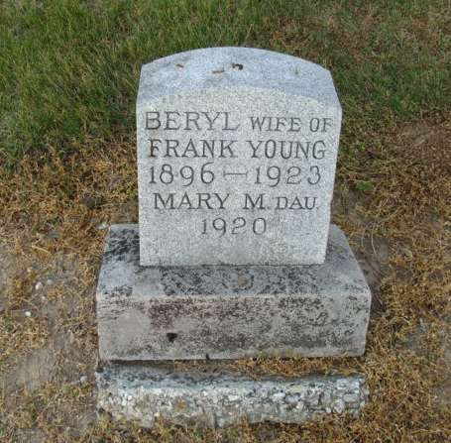
Photo by Alicia Kneuss

No obit found at this time

