Mary Alice (McCurdy) Young
March 19, 1866 – July 1, 1944

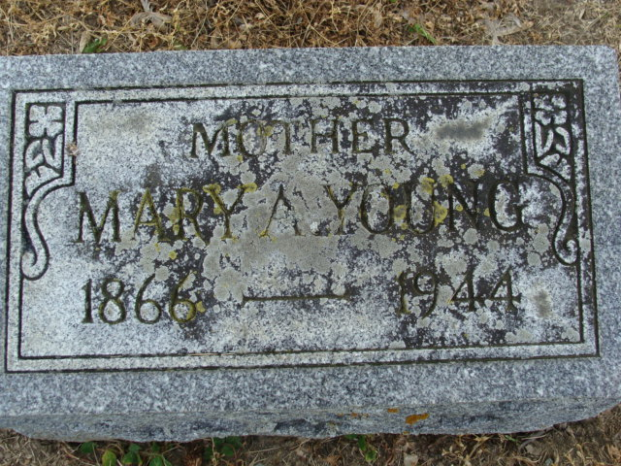
Photo by Alicia Kneuss

Mary Young
in the Indiana, U.S., Death Certificates, 1899-2011
Name: Mary Young
Gender: Female
Race: White
Age: 78
Marital status: Widowed
Birth Date: 19 Mar 1866
Birth Place: Sheldon Ind
Death Date: 1 Jul 1944
Death Place: Ft Wayne, Allen, Indiana, USA
Spouse: John Young
Informant: Frank Young; Decatur, Indiana
Burial: July 3, 1944; Decatur Cemetery

**
Marriage • Indiana Marriages, 1811-2019
Name John W Young
Sex Male
Spouse's Name Mary Mccurdy
Spouse's Sex Female
Officiator's Name Charles A Hays
Marriage License Date 11 Jul 1892
Marriage License Place Allen, Indiana, United States
Page 25
Number of Images 1

