Marie (Stevens) Young
May 17, 1905 – August 12, 1927

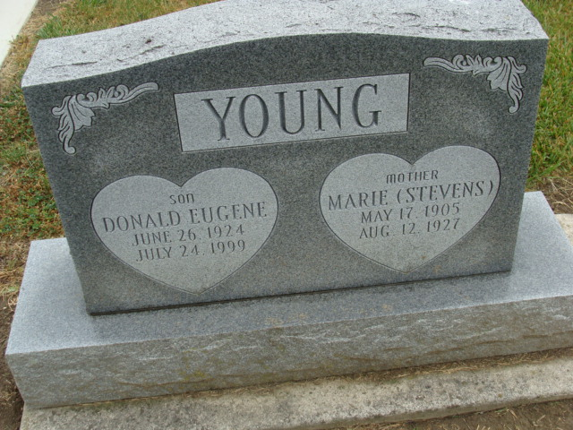
Photo by Alicia Kneuss

Marie Stevens Young, 22, of 2606 Perth street, Fort Wayne, former Adams county girl, died of uremic poisoning, at the Methodist hospital in Fort Wayne, at 9:05 o’clock this morning. Mrs. Young had been a patient at the hospital since Monday.
Marie Stevens Young was a daughter of Mr. and Mrs. Richard Stevens and was born east of Decatur, May 17, 1905. She was married to Leo D. Young, who survives. Other surviving relatives are the parents, who reside east of Decatur; one son, Donald Eugene; one sister, Lethevia; and six brothers, Roy, Morris, Chalmer, Waldo, Owen and Wayne, all at home.
Funeral services will be held at the Wood’s Chapel church, one mile east of Watt; at 3 o’clock Sunday afternoon, with the Rev. M. Sullivan, pastor, officiating. Burial will be made in Decatur cemetery.

Decatur Daily Democrat, Adams County, Indiana
August 12, 1927

