John W. Young
October 5, 1856 – May 28, 1927

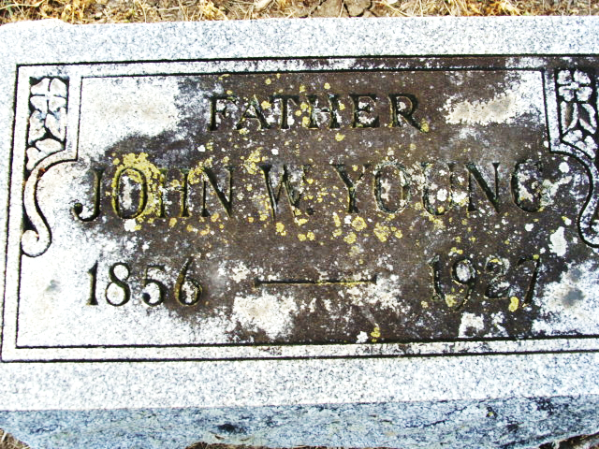
Photo by Alicia Kneuss

John W. Young
in the Indiana, U.S., Death Certificates, 1899-2017

Name John W. Young
Gender Male
Race White
Marital Status Married
Age 70
Birth Date 5 Oct 1856
Birth Place Indiana
Death Date 28 May 1927
Death Place Wayne, Wayne, Indiana, USA
Death Registration Date 1926-1927
Father Stephen Young
Mother Elizabeth McConnehey
Spouse Mary
Informant Richmond State Hospital records
Burial May 31, 1927; Decatur, Indiana

