Frank S. Young Sr.
July 10, 1894 – January 22, 1954

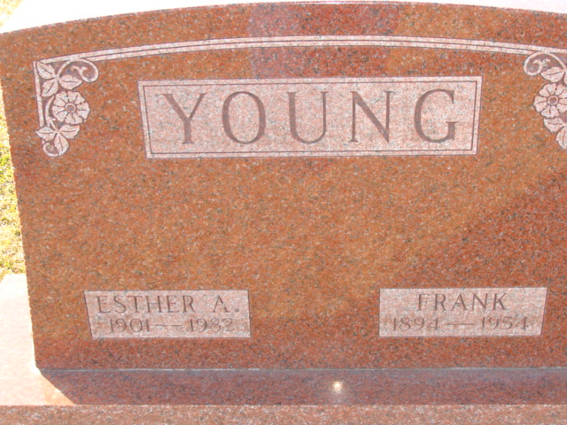
Photo by Alicia Kneuss

Indiana, U.S., Death Certificates, 1899-2017

Name Frank Young
Gender Male
Race White
Marital Status Married
Age 59
Military WW I
Birth Date 10 Jul 1894
Birth Place Illinois
Death Date 22 Jan 1954
Death Place Rural, Wayne, Indiana, USA
Death Registration Date 1954
Father John Young
Mother Mary McCarty
Informant Richmond State Hospital Records
Burial Jan 25, 1954 Decatur Cemetery

