Esther A. (Callow) Young
September 24, 1901 – June 23, 1982

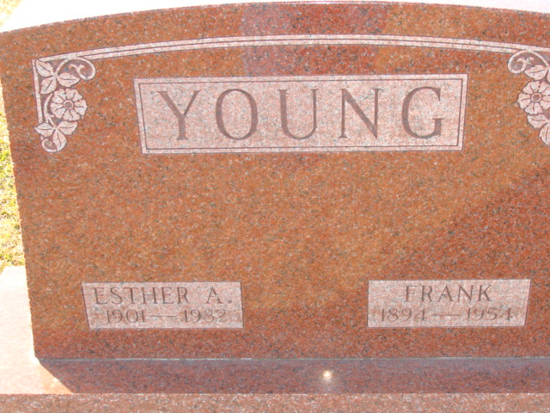
Photo by Alicia Kneuss

Indiana, U.S., Death Certificates, 1899-2017

Name Esther A. Young
[Esther A. Callow]
Gender Female
Race White
Marital Status Widowed
Age 80
Birth Date 24 Sep 1901
Birth Place Ohio
Death Date 23 Jun 1982
Death Place Decatur, Adams, Indiana, USA
Death Registration Date 1982
Father John Callow
Mother Lois King
Informant Frank Young, Jr.
Burial 6/25/1982 Decatur Cemetery

