Donald Eugene Young
June 26, 1924 – July 24, 1999

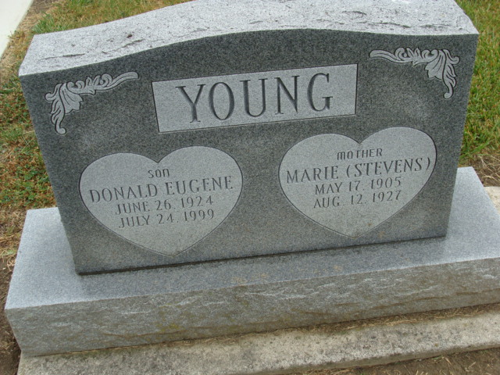
Photo by Alicia Kneuss

Donald E. Young, 75, of Fort Wayne, a World War II Marine Corps veteran, died Saturday, July 24, 1999, at home. The Fort Wayne native retired in 1982 from Navistar.
Surviving are daughters Maria Schnelker and Marilyn E. Smith, both of Fort Wayne; sons Michael L. and Steven V., both of Fort Wayne, and Gregory N.; three grandchildren; and two great-grandchildren.
Memorial services are 7 p.m. Friday at Hockemeyer & Miller Funeral Home, 6131 St. Joe Road. There is no calling. Memorials are to American Cancer Society.

News-Sentinel, Allen County, Indiana
July 28, 1999

