Beryl (Lhamon) Young
October 11, 1896 – October 3, 1923

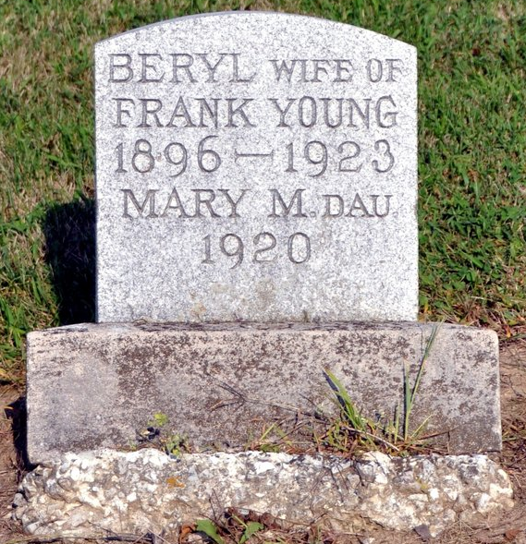
Photo by Deb Curry

Mrs. Young Buried Today

The funeral of Mrs. Frank Young was held from the Baptist Church this morning at 10 o'clock. Rev. F. D. Whiteseil officiating. Mrs. Young is the daughter of Albina Buhler, former owner of the Art Shop. Mr. Young is a well-known barber of Decatur. Mrs. Young died Friday evening after a long and lingering illness. She was interred in the Decatur Cemetery.

Decatur Daily Democrat, Adams County, Indiana
Monday, October 8, 1923

**
Indiana, U.S., Death Certificates, 1899-2017

Name Beryl Young
[Beryl Lhamon]
Gender Female
Race White
Marital Status Married
Age 26
Birth Date 11 Oct 1896
Birth Place Indiana
Death Date 3 Oct 1923
Death Place Decatur, Adams, Indiana, USA
Death Registration Date 1923
Father Thomas Lhamon
Mother Binia Campbell
Spouse Frank Young
Informant Frank Young; Decatur, Indiana
Burial October 8, 1923; Decatur, Indiana

