Aleta Elaine (Ratcliff) Young
July 11, 1930 – May 2, 2018

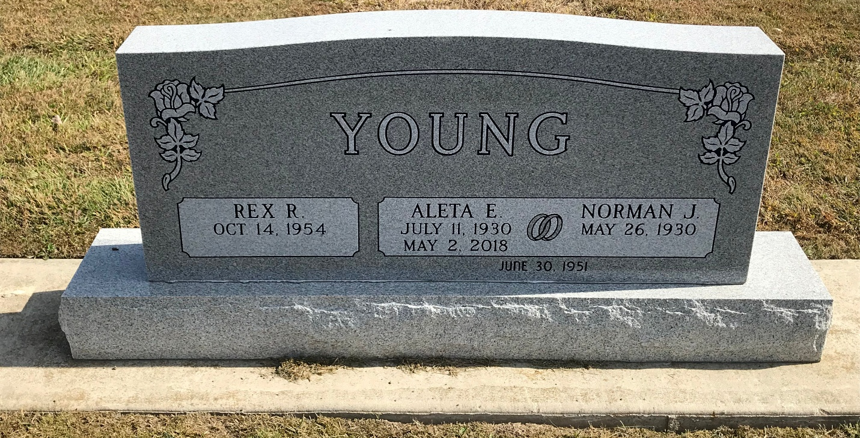
Photo by PLS

Aleta E. Young, 87, of Berne, IN passed away Wednesday, May 2, 2018 at Chalet Village. Aleta was born in Wells County on July 11, 1930 to the late Ora and Ireta (Shoaf) Ratcliff. On June 30, 1951, Aleta married Norman J. Young. Aleta was a former member of the Eastern Star.
She is survived by her husband, Norman J. Young of Berne; a son, Rex Young of Berne; a daughter, Trudi (Jeff) Bauermeister of Ossian; four brothers, Kay Ratcliff of Roanoke, Vernon Ratcliff of Ft. Wayne, Gene Ratcliff and Lynn Ratcliff both of Monroe; and two granddaugh-ters Dr. Kari Bauermeister of Easley, SC., Megan Bauermeister of Ossian, IN.
Graveside services will be held at 11:00am on Saturday May 5, 2018 at the Decatur Cemetery. Pastor Tom Brunstrup will be officiating.
Memorials may be given to Rock Steady Boxing Bluffton for Parkinson’s, through Haggard-Sefton-Hirschy & Zelt Funeral Home.

Haggard-Sefton-Hirschy & Zelt Funeral Home, Adams County, Indiana

