Mary Ellen Yost
November 30, 1923 – November 18, 1929

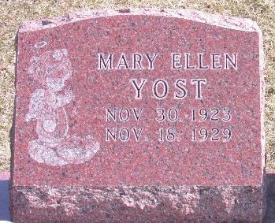
Photo by Trina

DECATUR CHILD EXPIRES MONDAY
Mary Ellen Yost Dies At Hospital Following Appendectomy

Mary Ellen Yost, 6, daughter of Mr. and Mrs. Attos Yost of this city, died at 8:21 o’clock Monday night at the Adams County Memorial hospital where she had been a patient for the last several days. Little Miss Yost became ill about a week ago and underwent an operation for appendicitis. Complications set in, causing her death last night.
Mary Ellen Yost was born in Decatur, November 30, 1923. She was the daughter of Mr. and Mrs. Attos Yost. The little girl was a pupil in the first grade of the Riley school until her illness. She was also a regular attendant of the Primary department of the Reformed Sunday school.
Surviving besides the parents are the grandparents, Mr. and Mrs. Sata Baumgartner of Decatur and Mr. and Mrs. John Miller of Van Wert, Ohio, and a sister, Ruth Irene, aged 3. The child also has a host of little friends in the Riley school and the Reformed Sunday school who join with the family in the hours of sorrow.
Funeral services will be held Thursday afternoon at 1:30 o’clock at the home, 1004 South Tenth street and at 2 o’clock at the Reformed church. Burial will be made at the Decatur cemetery. The Rev. A. R. Fledderjohann will have charge of the services.

Decatur Daily Democrat, Adams County, Indiana
November 19, 1929

