Jay Jacob Yost
December 8, 1909 – March 15, 2008

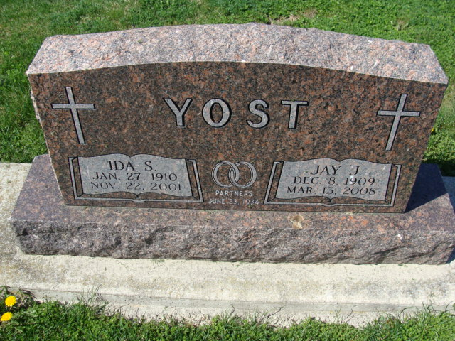
Photo by Alicia Kneuss

Jay Jacob "J.J." Yost, 98 years old of Berne, Indiana, and formerly of rural Decatur, passed away on Saturday, March 15, 2008 in the Swiss Village. He was born on Wednesday, December 8, 1909 in Adams County, Indiana the son of the late John Yost and the late Emma (Baumgartner). He married the late Ida S. Yost on June 23, 1934 in the Salem Reform Church and she passed away on November 22, 2001.
He was a member of Zion Lutheran Church, Decatur where he served on the Board of Evangelism from 1992 to 1994 and Zion Lutherans for Life from 1993 to 1999. J.J. was in the Pig Club from 1920 to 1922 and he organized and led the "Variety Farmers" 4-H Club in Washington Township from 1942 to 1943. A member of the Farm Bureau from 1942 to 2003, he was an editor for the Adams County Farm Bureau - Indiana Farm Bureau Co-Op News monthly edition from 1947 to 2003. He also enjoyed reading, committee work and the offices he held for the Farm Bureau and at the church.
J.J. graduated in 1928 from Monroe High School. He was a lifelong Washington Township farmer and had been employed at the General Electric on Broadway & Winter Street in Fort Wayne from 1929 to 1942.
Survivors include his brother-in-law, Raymond C. Borne of Fort Wayne, Indiana and sister-in-law, Eulalia Augsburger of Decatur, Indiana. Preceding Jay in death were two brothers-in-law, Noah & Chalmer Borne and three sisters-in-law, Esther Bieberich, Frances Jaberg & Edna Stewart.
Funeral services will be held at 10:30 a.m. Wednesday, March 19, 2008 in the Zion Lutheran Church with Rev. Daniel Gadbaw officiating. Interment will follow in the Decatur Cemetery. Friends will be received from 12:00 p.m. to 2:00 p.m. Tuesday in the Swiss Village, Berne, Indiana; 4:00 p.m. to 8:00 p.m. Tuesday in the Zwick & Jahn Funeral Home and one hour prior to calling at the church on Wednesday. Preferred memorials are to Zion Lutheran Church or Swiss Village.

Zwick & Jahn Funeral Home, Adams County, Indiana
March 16, 2008

