Ida S. (Borne) Yost
January 27, 1910 – November 22, 2001

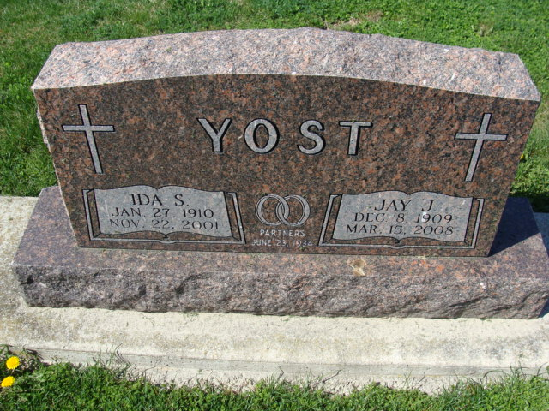
Photo by Alicia Kneuss

Ida S. Yost, 91, of Berne, a member of Zion Lutheran Church, Decatur, died Thursday, Nov. 22, 2001, at Adams County Memorial Hospital. The Preble native was a homemaker and worked at Decatur Industries from 1959 to 1980.
Surviving are her husband Jay J.; sisters Eulalia Augsburger of Decatur, and Edna Stewart of Fort Wayne; brothers Raymond Borne and Chalmer Borne, both of Fort Wayne. She was preceded in death by two sisters; and one brother.
Services are 2 p.m. Sunday at Zion Lutheran Church, Decatur, with calling 1 to 5 p.m. today and 10:30 a.m. to noon Sunday in Zwick & Jahn Funeral Home, Decatur, and one hour before services at the church. Burial will be at Decatur Cemetery. Memorials are to the church or Swiss Village.

News-Sentinel, Allen County, Indiana
November 24, 2001

