Ida M. (Liby) Yost
June 13, 1897 – May 22, 1982

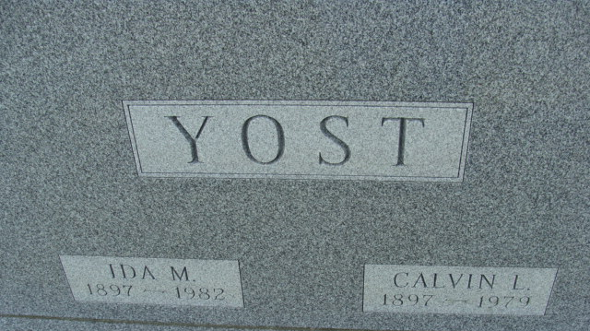
Photo by Alicia Kneuss

IDA M. YOST

Ida M. Yost, 84, a resident of Swiss Village in Berne since February, died there Saturday morning. A former resident of 115 Limberlost Trail in Decatur, she had not been ill, and death was unexpected.
The widow of Calvin L. Yost, she was a housewife, a member of Zion United Church of Christ and the Phoebe Bible Class, and a member of the Decatur Rose Garden Club. She was born June 13, 1897, in Adams County, the daughter of William and Amanda Breiner-Liby, and was married to Mr. Yost on May 24, 1952; he passed away on July 7, 1979. She was a lifelong resident of Adams County.
Survivors include a son, Robert L. Yost, Fort Wayne, and a daughter, Mrs. James (Alice) Bixler, also of Fort Wayne; seven grandchildren and seven greatgrandchildren. A brother, Floyd Liby, passed away last September 7.
Funeral services will be held at 10:30 a.m. Tuesday at Zwick-Boltz & Jahn Funeral Home, Rev. Lawrence Balleine and Rev. William C. Feller in charge, and burial will be in the Decatur Cemetery. Friends may call at the funeral home from 3 to 8 p.m. today.
Preferred memorials are to the Zion United Church of Christ.

Decatur Daily Democrat, Adams County, Indiana
May 24, 1982

