Calvin L. Yost
May 5, 1897 – July 7, 1979

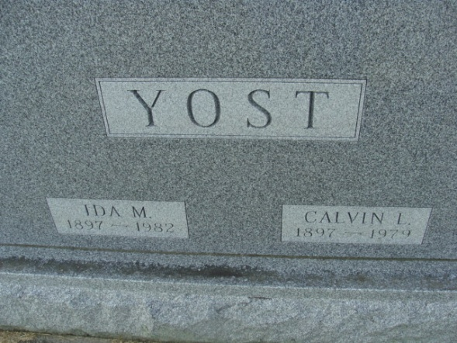
Photo by Alicia Kneuss

Indiana, U.S., Death Certificates, 1899-2017

Name Calvin L. Yost
Gender Male
Race White
Marital Status Married
Age 82
Birth Date 5 May 1897
Birth Place Indiana
Death Date 7 Jul 1979
Death Place Decatur, Adams, Indiana, USA
Death Registration Date 1979
Father Samuel Yost
Mother Emma Klopfenstein
Spouse Ida Liby Yost, informant
Burial 7/11/1979 Decatur Cemetery

**
Collection: Indiana Marriages 1811-1959

Groom's name: Calvin Yost; Groom's race or color: White; Groom's birth date: ; Groom's birthplace: , Wells, Indiana; Groom's residence: Decatur, , Indiana; Groom's number of marriages: 1st; Groom's father's name: Sam Yost; Groom's mother's name: Klopfenstein
Bride's name: Ida May Liby; Bride's race or color: White; Bride's birth date: ; Bride's birthplace: , Adams, Indiana; Bride's residence: , Adams, Indiana; Bride's number of marriages: 1st; Father of bride's name: Wm Liby; Mother of bride's name: Briener
Marriage date: 24 May 1922; Marriage place: ; Official's name:
Record number: 5989; Film number: 2321469; Digital GS number: 4186024; Image number: 00488; Number of images: 1

