Attos V. Yost
June 5, 1895 – January 12, 1944

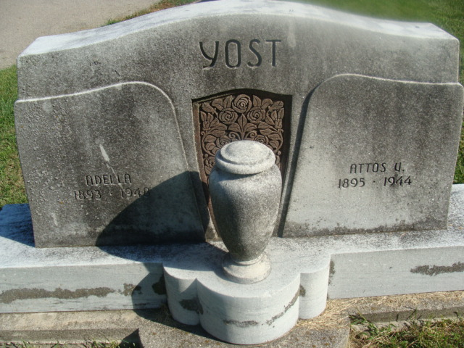
Photo by Alicia Kneuss

Yost Funeral Rites Saturday Afternoon

Friends may view the body of A. V. “Ott” Yost at the Zwick funeral home any time until 10 o’clock Saturday morning, when it will be removed to the home. At 1:30 o’clock Saturday afternoon strictly private services will be held in the home and at 2 o’clock the funeral services will be held in Zion Evangelical and Reformed church. Burial will be in the Decatur cemetery, where graveyard military services will be conducted by the American Legion.
Mr. Yost died Wednesday of injuries sustained in an accident when his truck overturned on U. S. highway 224 just east of the Ohio line.

Decatur Daily Democrat, Adams County, Indiana
January 14, 1944

