Adella (Miller) Yost
September 20, 1893 – July 13, 1948

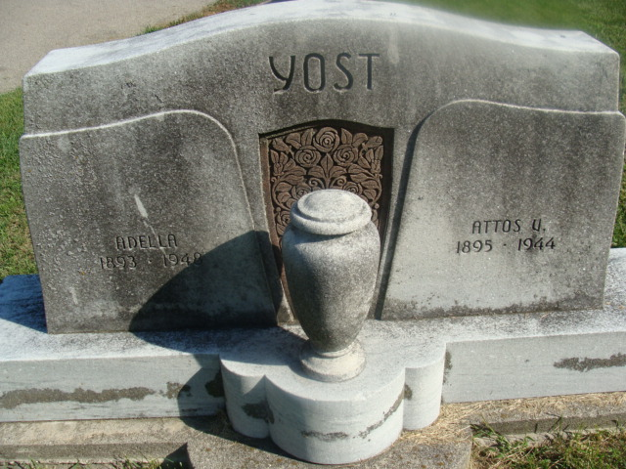
Photo by Alicia Kneuss

Decatur, July 13 – Mrs. Adella Yost, 54, a native of Preble Township died at 1:45 am today in the Castle Convalescent Home at Van Wert, Ohio where she had been bedfast five years. She was a member of the Zion Evangelical and Reformed Church.
Surviving are a son, Sam and a daughter, Mrs. Ruth Hunter, at home; a granddaughter; three brothers, Hubert Miller of Van Wert, Otto F. Miller, St. Petersburg, Florida and Edwin H. Miller, Delphos, Ohio and two sisters, Mrs. B. M. Schultz, Cleveland and Mrs. Raylor Durflinger, Fort Wayne.
The body was returned here to the Zwick Funeral Home where friends may call after 7:30 pm Wednesday. Services will be conducted at 2:30 pm Friday in the Zion Evangelical and Reformed Church with the Rev. William C. Feller officiating. Burial will be in Decatur Cemetery.

Journal-Gazette, Allen County, Indiana
July 14, 1948
Page 15

**
Name: Adella Yost
Sex: Female
Age: 53y 9m 23d
Death Date: 13 Jul 1948
Death Place: Van Wert, Pleasant Township, Van Wert, Ohio, USA
Death Place (Original): Van Wert, Van Wert, Ohio
Marital Status: Widowed
Occupation: HW
Race: W
Father's Name: John Miller
Mother's Name: Emma Reppert
Cemetery: Decatur Cemetery
Address: 1004 N. Adams
Residence Place: Decatur, Adams, Indiana
Birth Date: 20 Sep 1893
Birthplace: Preble Twp., Adams Co., Ind.
Burial Date: 17 Jul 1948
Father's Birthplace: Indiana
Mother's Birthplace: Indiana
Spouse's Name: Atlas V. Yost
Informant: Mrs. Ruth Hunter; Decatur, Indiana
Source Details: item 18 cn 112
Indexing Batch: B01445-3
GS Film Number: 1952880
Digital Folder Number: 004254316
Digital Folder Number: 004254316
Image Number: 1570

"Ohio, County Death Records, 1840-2001," database with images, FamilySearch

