Sarah A. York
1841 – February 13, 1905

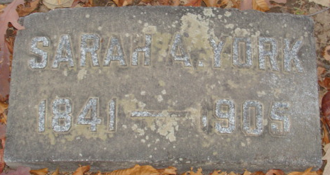
Photo by Alicia Kneuss

March York
in the Indiana, U.S., Death Certificates, 1899-2017

Name Sarah York
Gender Female
Race White
Age 66
Birth Date abt 1839
Birth Place Michigan
Death Date 13 Feb 1905
Death Place Decatur, Adams, Indiana, USA
Death Registration Date 1905
Spouse James York
Informant Frederick Corey; Decatur, Indiana
Burial February 15, 1905; Maplewood Cemetery

