Mary K. York
August 13, 1882 – March 26, 1960

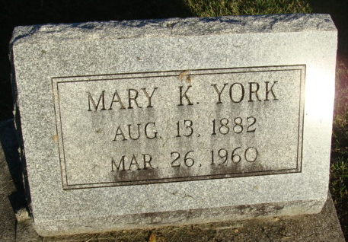
Photo by Alicia Kneuss

Ohio, U.S., Death Records, 1908-1932, 1938-2022

Name Mary K York
Gender Female
Race White
Marital Status Widowed
Death Age 77
Birth Date Abt 1883
Residence Place Dayton, Montgomery, Ohio, USA
Death Date 26 Mar 1960
Death Place Dayton, Montgomery, Ohio, USA
Certificate Number 23553
Inquest Hospital Franciscan Med Cntr Dayton Cam
Inquest Questions Certifier: Physician; Autopsy Performed?: Yes, Used For Certification;

