Shawn G. Yoquelet
October 30, 1970 – October 8, 2014

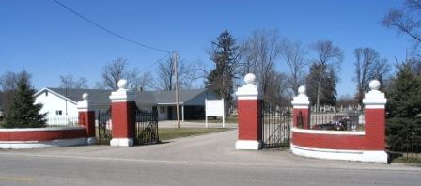
Photo by Barbara Baker Anderson

Shawn G. Yoquelet, 43 years old of Avilla, Indiana, passed away on Wednesday, October 8, 2014 following a traffic accident in Noble County. He was born on Friday, October 30, 1970 in Fort Wayne, Indiana the son of the late Byron J. Yoquelet and the late Colleen (Mossburg) Yoquelet. He married Melissa J. Hudson on July 24, 1989 in Van Wert, Ohio.
Shawn was a 1990 graduate of Bellmont High School and was a member of the Moose Lodge #33 in Muncie, Indiana.
Surviving are his wife, Melissa J. Yoquelet of Avilla; son, Shawn B. Yoquelet of Fort Wayne; son, Nicholas J. Yoquelet of Avilla; daughter, Alyssa J. Yoquelet of Avilla; sister, Malynda (Gordy) Custer of Van Wert; brother, Bill (Cindy) Moffett of Decatur; sister, Brenda Gray of Decatur; brother, Ed (Amy) Stove of Decatur; brother, Corey (Kobi) Yoquelet of Oakland, CA; brother, Carey Yoquelet of Garrett; father-in-law, James (Marcia) Hudson of Muncie; and mother-in-law, Sandra (Richard) Fravel of Geneva.
Funeral services will be held at 1:00 p.m. Monday, October 13, 2014 in the Zwick & Jahn Funeral Home in Decatur with Pastor Tom Clothier officiating. Interment will follow in the Decatur Cemetery.
Friends will be received from 12 noon to 4 p.m., Sunday, October 12 in the Zwick & Jahn Funeral Home in Decatur and one hour prior to the service at the funeral home on Monday.
Preferred memorials are to the donor's choice.

Zwick & Jahn Funeral Home, Adams County, Indiana
October 9, 2014

