Colleen J. (Mossburg) Yoquelet
February 8, 1941 – January 11, 2008

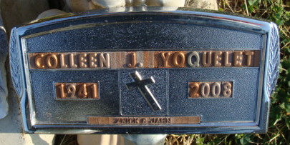
Photo by Alicia Kneuss

Colleen Joan Yoquelet, 66 years old of Decatur, Indiana, passed away at 12:20 a.m. on Friday, January 11, 2008 in the Adams Memorial Hospital located in Decatur, Indiana. Colleen was born on Saturday, February 8, 1941 in Bluffton, Indiana the daughter of the late Carl Mossburg and the late Irma (Foster) Mossburg. Colleen was a waitress in Ft. Wayne for many years and following the birth of her children, she was a loving, caring, and generous mother and grandmother.
Surviving are her daughter, Malynda (Gordy) Custer of Van Wert, Ohio, son, Bill (Cindy) Moffett of Decatur, Indiana, daughter, Brenda Gray of Ft. Wayne, Indiana, son, Ed (Amy) Stove of Decatur, Indiana, son, Shawn (Melissa) Yoquelet of Avilla, Indiana, son, Corey Yoquelet of Oakland, California, son, Carey Yoquelet of Decatur, Indiana, brother, Donald (Sue) Mossburg of Ft. Wayne, Indiana, sister, Carlene Girardot of Ft. Wayne, Indiana, and fourteen grandchildren.
Preceding Colleen in death were one brother, Darrel Eugene Mossburg; and one sister, Rebecca Rodriquez.
Funeral services will be held at 2:00 p.m. Monday, January 14, 2008 in the Zwick & Jahn Funeral Home with the Rev. Wes Kuntzman officiating. Interment will follow in the Decatur Cemetery, Decatur, Indiana. Friends will be received one hour prior to the service on Monday at the funeral home. Preferred memorials are to the family.

Zwick & Jahn Funeral Home, Adams County, Indiana
January 12, 2008

