John Henry Yocum
December 17, 1912 - 1945

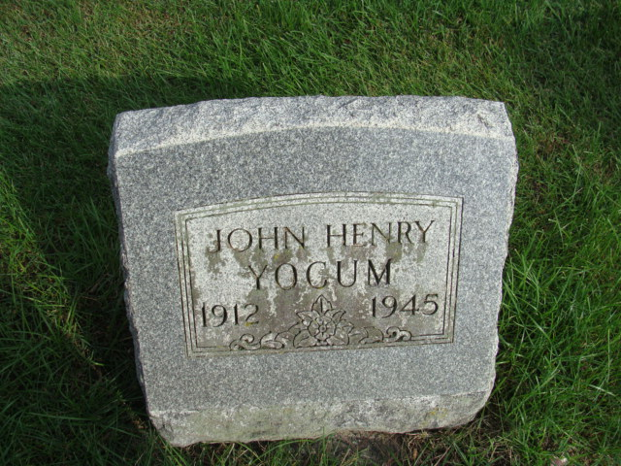
Photo by Alicia Kneuss

U.S., World War II Draft Cards Young Men, 1940-1947

Name John Henry Yocum
Race White
Age 27
Birth Date 17 Dec 1912
Birth Place Decatur, Indiana
Residence Place Mendon, Mercer, Ohio
Registration Date abt 1939
Registration Place Massillon, Ohio
Employer None
Height 5-7
Weight 155
Complexion Freckled
Hair Color Brown
Eye Color Blue
Next of Kin Mrs Ada Yocum, mother

