Henry E. Yocum
June 15, 1881 – January 23, 1961

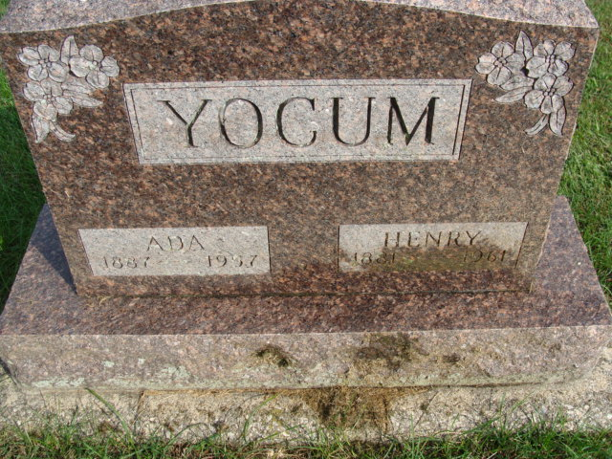
Photo by Alicia Kneuss

HENRY E. YOCUM

ROCKFORD – Henry E. Yocum, 79, died at 8:45 a.m. Monday in Gibbons Hospital, Celina, where he had been a patient for five days. He had suffered several strokes in the past week. Born June 15, 1881 in Mercer County, he was a son of Elmer and Lydia (Miller) Yocum. He had been a real estate dealer. He was married to Ada Drummond July 27, 1907 and she died in 1957.
Surviving are three daughters, Mrs. Dora Wittung of Rockford, Mrs. Margaret Smith of Detroit, Mich., and Mrs. Evelyn Whetstone of Mendon; a son, Doyle, of Willshire; six grandchildren and three great-grandsons; three sisters, Mrs. Frank Parrish of Decatur, Ind., Mrs. James Agler of Van Wert and Mrs. Roy Darby of Jackson, Mich.; and one brother, Gus, of Van Wert.
Services will be held at 2 p.m. Wednesday in the Ketcham's Funeral Home, Rockford, with Rev. Emery Moyer officiating. Burial will be in Maplewood Cemetery, Decatur, Ind. Friends may call at the funeral home after 1 p.m. today.

Lima News, Allen County, Ohio
Tuesday, Jan. 24, 1961

