Ada (Drummond) Yocum
June 8, 1887 – April 13, 1957

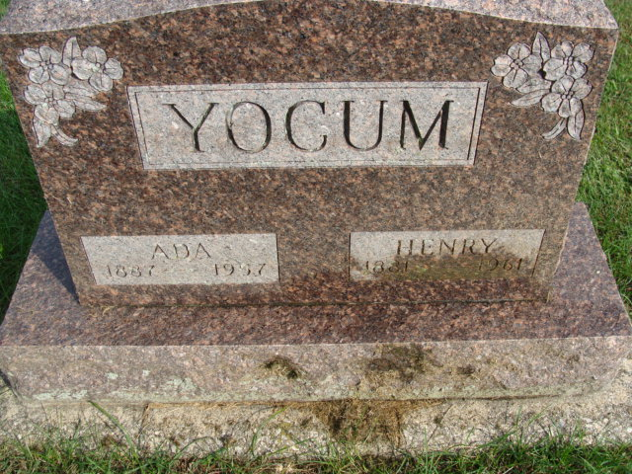
Photo by Alicia Kneuss

MRS. HENRY YOCUM

ROCKFORD – Services for Mrs. Ada Yocum, 69, of here, who died at 7 p.m. Saturday in the Gibbons Hospital, Celina, will be at 2 p.m. Tuesday in the Ketcham Funeral Home.
Mrs. Yocum is survived, besides her husband, Henry, by three daughters, Mrs. William Whetstone, and Mrs. Lester Wittung, both of Rockford and Mrs. Norman Smith, Mishawaka, Ind.; a son, Doyle, Willshire and 10 grandchildren.
The body will remain in the funeral home where friends may call until time of services. Burial will be in Maplewood Cemetery, Decatur, Ind.

Lima News, Allen County, Ohio
Monday, April 15, 1957
**

Family Search Record - Indiana Marriages

groom: Henry E Yocum; groom's race: White; groom's date of birth: 15 Jun 1881; groom's place of birth: Mendan, Mercer, Ohio; groom's residence: Decatur, , Indiana; groom's number of marriage: 1st; groom's father: Elmer Yocum; groom's mother: Anna Miller
bride: Ada Drummond; bride's race: White; bride's date of birth: 08 Jun 1887; bride's place of birth: Decatur, Adams, Indiana; bride's residence: Decatur, Adams, Indiana; bride's number of marriage: 1; bride's father: Daniel Drummond; bride's mother: Martha Bevard
date of license: 25 Jul 1906; place of marriage: , Adams, Indiana
digital folder number: 4186021; number of images: 1

