Harry L. Yahne
July 21, 1904 – April 6, 1955

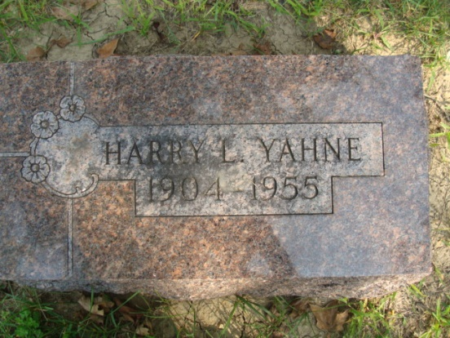
Photo by Alicia Kneuss

Indiana, U.S., Death Certificates, 1899-2017

Name Harry L Yahne
Gender Male
Race White
Marital Status Single
Age 50
Birth Date 21 Jul 1904
Birth Place Decatur, Indiana
Death Date 6 Apr 1955
Death Place Fort Wayne, Allen, Indiana, USA
Death Registration Date 1955
Father Frank Yahne
Mother not listed
Informant Mrs. C. P. Foreman
Burial 4-11-1955 Maplewood

