Mary Jane (Archbold) Yager
August 16, 1841 – September 6, 1911

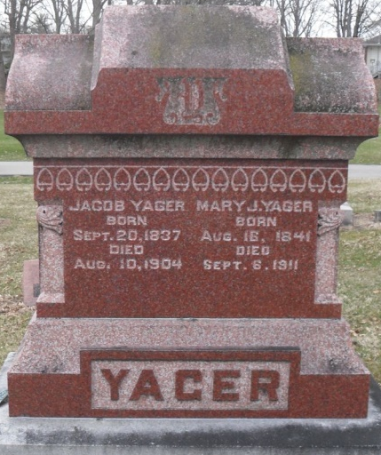
Photo by Deb Curry

Indiana, U.S., Death Certificates, 1899-2017

Name Mary Jane Yager
[Mary Jane Archibald]
Gender Female
Race White
Marital Status Widow
Age 71y 22d
Birth Date 16 Aug 1840 (sic – stone 1841)
Birth Place Ohio
Death Date 6 Sep 1911
Death Place Decatur, Adams, Indiana, USA
Death Registration Date 1911
Father Thomas Archibald
Mother Pheobe Valentine
Spouse Jacob Yager
Informant Charles Yager
Burial Decatur Cem 9-8-1911

