Kathryn L. Yager
August 31, 1925 – November 2, 2014

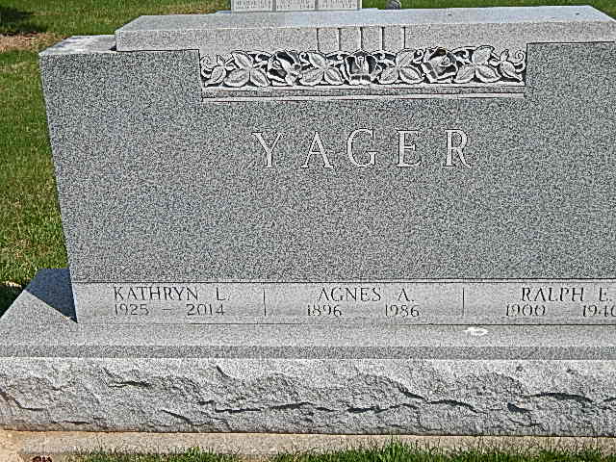
Photo by Alicia Kneuss

Kathryn L. Yager, 89 years old of Decatur, Indiana, passed away at 7:20 a.m. on Sunday, November 2, 2014 in the Adams Woodcrest located in Decatur. Kathryn was born on Sunday, August 16, 1925 in Decatur, Indiana the daughter of the late Ralph Yager and the late Agnes (Sellemeyer) Yager.
Kathryn was a member of the Zion United Church of Christ in Decatur and the Indiana Retired Teachers Association. Kathryn was a high school teacher at Evergreen Park High School in Chicago, Illinois and had also taught in Hoagland. She graduated from Heidelberg University with a BA in Education and received her Master's Degree at Columbia University.
Surviving are her cousin, Richard A. (Renee) King of Payne, OH; and many cousins.
Funeral services will be held at 10:00 a.m. Friday, November 7, 2014 in the Zion United Church of Christ with Rev. Randy Rossman officiating. Interment will follow in the Decatur Cemetery.
Friends will be received from 6-8 p.m. Thursday, November 6, 2014 in the Zwick & Jahn Funeral Home, Decatur, IN and one hour prior to the service at the church on Friday.
Preferred memorials are to Zion United Church of Christ; Angel Corps; or Family LifeCare of Berne.

Zwick & Jahn Funeral Home
November 3, 2014

