Jacob Yager
September 20, 1837 – August 10, 1904

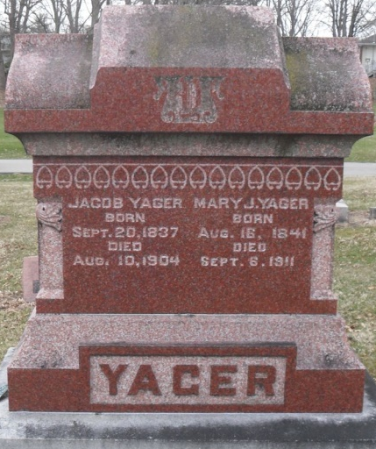
Photo by Deb Curry

U.S. Civil War Soldier Records and Profiles
Name: Jacob Yager; Enlistment Date: 10 Mar 1864; Rank at enlistment: Private; State Served: Indiana; Survived the War: Yes; Service Record: Drafted to Company D, Indiana 51st Infantry Regiment on 03 Oct 1864. Mustered out on 25 Aug 1865.
Sources: Report of the Adjutant General of the State of Indiana
**
Will of Jacob Yager
Name in Record Reason for Being in Record Date of Record
Jacob Yager Of Decatur; makes his last will & testament Aug. 8, 1904
Mary J. Yager Wife; inherits entire estate
Margaret J. France Daughter; to share estate after death of mother
Lydia J. Shamp Daughter; to share estate after death of mother
Phoebe V. Hite Daughter; to share estate after death of mother
Charles W. Yager Son; to share estate after death of mother
Charles W. Yager Son; appointed executor of will of Jacob Yager
James T. Merryman Witnessed Jacob Yager making his last will
Simeon B. Fordyce Witnessed Jacob Yager making his last will
Jacob Yager Died Aug. 10, 1904
James T. Merryman Subscribing witness; oath of death & validity of will Aug. 13, 1904
David Gerber Clerk; will has been admitted to probate Aug. 13, 1904

**
JACOB YAGER, was born in Huron County, Ohio, September 20, 1837. His parents, Jacob and Margaret (Wysup) Yager, came to Adams County in July, 1838. His grandfather, John Yager, came from Germany when seven years of age and settled in Pennsylvania. The grandmother Yager probably came from the old country. His ancestors on both sides were of the Protestant faith, and were generally farmers. About the year 1834 the grandfather came to this county and entered two sections of land, which he divided with his children, who were nine in number, six sons and three daughters - Francis, Henry, Peter, Samuel, Jacob, Sarah, Polly and Catherine. The parents were married in Ohio, and began their home life in the forest of Preble Township, Indiana. The land had no improvements whatever. Wolves, bears, etc., were uncomfortably plenty, and deer, and other wild game, had been almost entirely undisturbed. The tract of 100 acres which Jacob's father received cost about $125 at this time. The family went to work with a will; tree after tree was felled and acre after acre was cleared until this part of the wilderness became a productive farm, and the old log cabin, with its puncheon floor, after many years of faithful service was supplanted by modern buildings. When the parents came to this county there were very few settlers. There was no county seat, and papers and deeds were recorded at Fort Wayne. Mr. Yager's parents had five children - John, Jacob, George, Sarah and Polly Ann; Jacob, Sarah and George are living.
After remaining on the homestead until he was twenty five years of age, aiding in the improvement and cultivation of the farm, Jacob Yager and Mary Jane Archibald were united in marriage October 24, 1861. They began domestic life in Preble Township, settling upon a forty-acre tract which Jacob received from his father. The land was partially cleared, but had no buildings or other improvements. After three or four years forty acres more were added to the original tract, and a frame barn and a hewed-log house were built. They lived on this place eleven years, then removed to Decatur, where they resided two and a half years, then moved to St. Mary's Township upon a beautiful tract of land, comprising 197 acres, situated about three quarters of a mile from Pleasant Mills Village. It is one of the finest farms in the township, having 150 acres of improved land, and being well watered by two creeks, or branches, which renders it valuable as a stock farm as well as for agricultural purposes.
Mrs. Yager was born August 16, 1840, daughter of Thomas and Phebe (Valentine) Archibald who were probably natives of Ohio and of Irish ancestry. In a very early day her paternal grandparents removed to the Territory of Indiana and entered 160 acres of land in Wells County, where they lived until their death. Her parents removed to the same county, probably in the year 1848 where the father purchased eighty acres of land. Her ancestors were all Protestants, and one of her uncles, John Nevett, was a minister. Her great-grandfather served in the war of 1812, and her mother's brother, William Valentine, served in the war with Mexico, during which he received an injury.
Jacob Yager and his brother John were soldiers in the late war, John serving in Company C, Thirteenth Indiana Cavalry, and Jacob being a member of Company D, Fifty-first Indiana Infantry. Jacob was mustered into the service at Indianapolis in 1863, from which point his regiment was ordered to Nashville, thence to Pulaski, where the regiment was attacked by the rebel General Hood, about the first of December, 1864, and was forced to retreat, having only about half the force of the enemy. On this retreat many very bloody and hotly contested battles were fought - Spring Hill, Columbia, and others, until finally the historical stand was made at Nashville between Generals Thomas and Hood. Here every precantion was taken and every arrangement made for the desperate encounter soon to be made. The breast works of the rebels and the federals were in close proximity, and the men could converse with one another. Many little trades were made by the pickets on both sides. The crisis finally came on the 15th of December, 1864, and on the 16th the battle had its full force. Mr. Yager's regiment was engaged almost the entire day, during which time he was wounded in the ear. This produced paralysis of the jaw. After about six months the ball was extracted. On the evening of that dreadful day the regiment, which in the morning had answered to 900 names, could muster only about 300 names, the remainder having been sacrificed in battle. The dead were literally strewn over the ground and the scene of death was all that the imagination can picture. Mr. Yager was taken to the field hospital, thence to Nashville, thence to Jefferson Hospital, Indiana, and August 26, 1865, he received an honorable discharge for faithful and patriotic service.
When he arrived home he continued the occupation of farming, which he has continued to the present time. He has been honored with various official positions, viz., constable, assessor of Preble Township six years, city marshal of Decatur, has also been guardian, and at present is commissioner of Adams County, serving his second term. His father died June 16, 1886, and his mother January 6, 1887, at the residence of her son Jacob, aged seventy-three years, eleven months and five days. She was a member of the Baptist church a great many years.
Mr. and Mrs. Yager have had five children - Ida May, born September 8, 1876, died March 1, 1880; Charles William, born August 5, 1866; Margaret Jane, born January 16, 1863; Lydia Adaline, born November 26, 1868; Phebe Viola, born October 20, 1872.

Biographical and Historical Record - Adams and Wells Co. Indiana Lewis Publishing Co. Chicago, IL 1887

