Frank E. Yager
May 2, 1878 – October 10, 1955

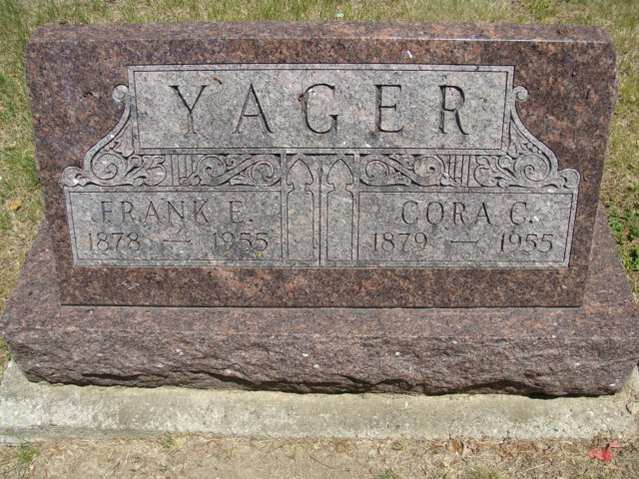
Photo by Alicia Kneuss

Indiana, U.S., Death Certificates, 1899-2017

Name Frank E Yager
Gender Male
Race White
Marital Status Widowed
Age 77y 5m 8d
Birth Date 2 May 1877
Birth Place French Twp, Adams Colorado
Death Date 10 Oct 1955
Death Place Bluffton, Wells, Indiana, USA
Death Registration Date 1955
Father Albert Yager
Mother not listed
Informant Luster Yager
Burial 10/12/1955 Decatur Cemetery

