Daniel Yager
September 20, 1845 – October 30, 1912

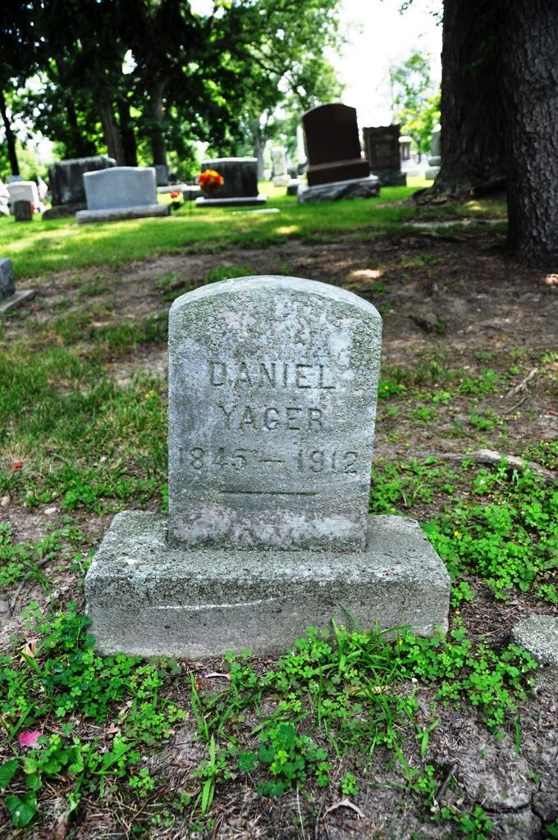
Photo by Deb Curry

LIFELESS BODY FOUND IN BED BY HIS WIFE
Daniel Yager, Old Time Resident, Passed Away During Night
PARALYSIS THE CAUSE
In Employ of City Street Department, Had Worked Tuesday.

Daniel Yager, for the past thirteen years a resident of Huntington, passed away some time Tuesday night, his lifeless body being found in bed by the wife on arising Wednesday morning. Mrs. Yager, as was her custom, arose at five o’clock but in an endeavor to awaken the husband received no response. Thinking that he was seriously ill and in an unconscious state, she hurriedly called a physician but upon the arrival of the latter Mr. Yager was found to be dead. Death was due to paralysis suffered during the night and by the time the physician arrived he had been dead several hours. The deceased, for the past few years in the employe of the city in the street department, worked all day Tuesday and upon returning home in the evening remarked to the wife that he was feeling unusually well.
Born in Adams county, Indiana, September 20, 1845, he married Miss Amanda Drague of Allen county on July 4, 1867. For the five succeeding years Mr. Yager lived in Allen county and at the expiration of that time moved to Decatur. Here he engaged in the hotel business until thirteen years ago when they moved to Huntington. For about six years after coming here he operated the Spencer house. From that time he had worked at various places about the city, the majority of the time in the city street department.
Besides the wife, two children survive him. They are Mrs. Fred Bender of Pleasant Mills, Adams county and John Yager of Frankfort.
No definite funeral arrangements had been made Wednesday pending the arrival of the son.

Huntington Herald, Huntington County, Indiana
Wednesday, October 30, 1912

