Cora C. (Martin) Yager
May 31, 1879 – January 31, 1955

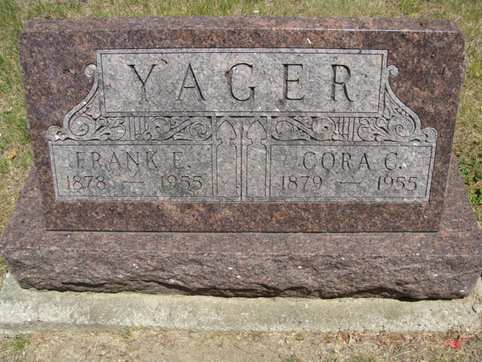
Photo by Alicia Kneuss

Cora Yaker
in the Indiana, U.S., Death Certificates, 1899-2017
Name Cora Yager
[Cora Martin]
Gender Female
Race White
Marital Status Married
Age 75
Birth Date 31 May 1881
Birth Place Ohio
Death Date 31 Jan 1955
Death Place Bluffton, Wayne, Indiana, USA
Death Registration Date 1955
Father George Martin
Mother Lena Benedict
Informant None listed
Burial February 3, 1955; Decatur Cemetery; Decatur, Indiana

