Amanda Yager
1849 – June 21, 1913

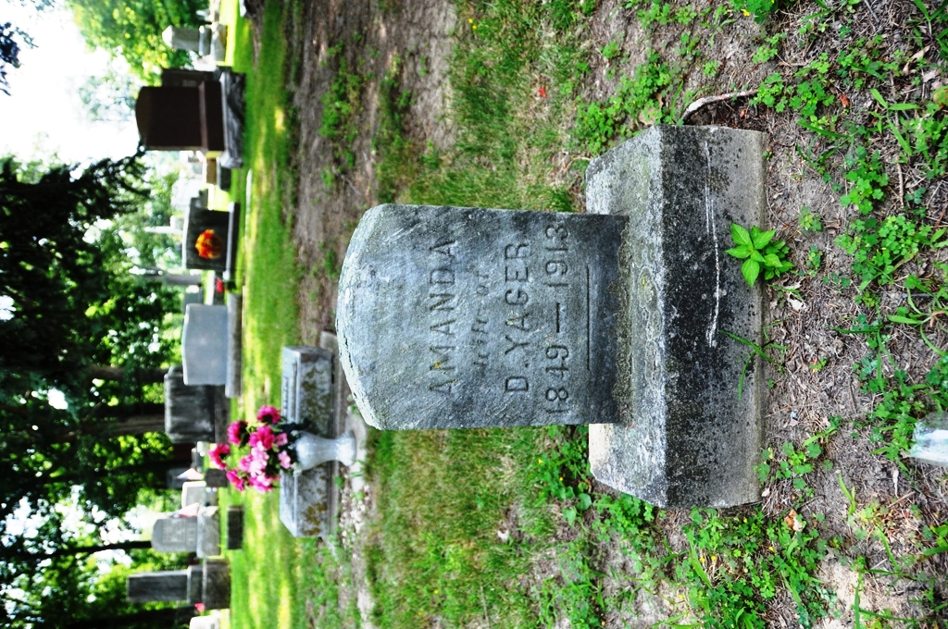
Photo by Deb Curry

Indiana, U.S., Marriages, 1810-2001

Name Amanda A Dragge
Gender Female
Event Type Marriage Registration (Marriage)
Marriage Date 3 Jul 1867
Marriage Place Indiana, United States
Spouse Daniel Yager
Page 64
FHL Film Number 002111268

