Agnes A. (Sellemeyer) Yager
July 12, 1896 – May 8, 1986

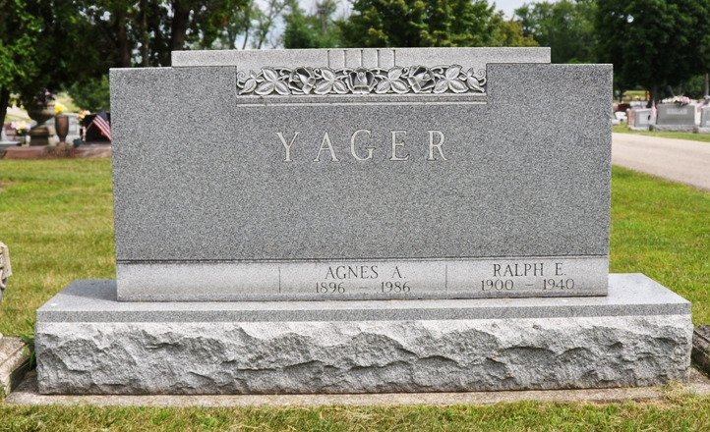
Photo by Deb Curry

Indiana, U.S., Death Certificates, 1899-2017

Name Agnes A Yager
[Agnes A Sellemeyer]
Gender Female
Race White
Marital Status Widowed
Age 89
Birth Date 12 Jul 1896
Birth Place Indiana
Death Date 8 May 1986
Death Place Decatur, Adams, Indiana, USA
Death Registration Date 1986
Father Herman Sellemeyer
Mother Sevilla Kohler
Informant Kathryn Yager, daughter
Burial 5/10/1986 Decatur Cemetery
**
Adams Public Library System (Decatur, IN) online obit abstracts
Publication: Decatur Daily Democrat; 08 MAY 1986
Title: Yager, Agnes A.; Subject: Obituaries -- Y -- 1980-1989
Abstract: Age: 89
Born: July 12, 1896
Daughter of: Herman & Serulla Kahler Schlemeyer
Spouse: Ralph E. Yager
Notes: DPL 6-347-3

