Sophia Kathryn (Gross) Wynn
November 28, 1879 – January 26, 1966

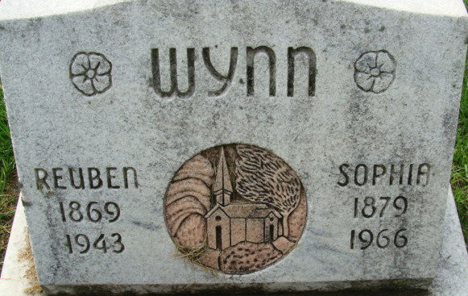
Photo by Alicia Kneuss

Sophia K Wynn
in the Indiana, Death Certificates, 1899-2011
Name: Sophia K Wynn
[Sophia K Gross]
Gender: Female
Race: Caucasian (White)
Age: 86
Marital status: Widowed
Birth Date: 28 Nov 1879
Birth Place: Ohio
Death Date: 26 Jan 1966
Death Place: Berne, Adams, Indiana, USA
Father: William Gross
Mother: Catherine Welch
Informant: Mrs. Harold Baughn; daughter; Decatur, Ind.
Burial: Jan. 28, 1966; Decatur Cem., Decatur, Ind.

