Rube Oliver Wynn
December 1, 1894 – April 8, 1982

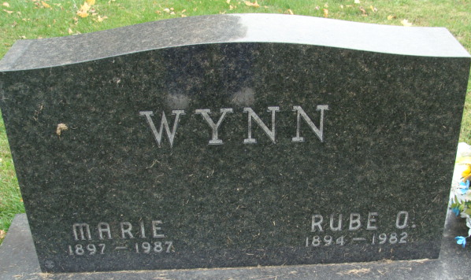
Photo by Alicia Kneuss

Rube O. Wynn, 87, 904 West Adams St., the father of boys' baseball in Decatur for more than half a century, lost his gallant struggle for life at 6 a.m. today at his home. Death followed a lengthy illness. He was a retired Adams County Memorial Hospital employee and previously had worked as a custodian at the Decatur Community Center and a number of schools in Decatur.
Mr. Wynn was also a member of the St. Mark's United Methodist Church and an honorary board member of the Decatur Little League, a league he helped found in the early 1950s. He was a member of the Moose Lodge and coached Moose teams for a number of years.
Born in Adams County on Dec. 1, 1894, he was the son of R.M. and Edith Smith-Wynn, and was united in marriage on March 3, 1916, to Marie C. Clowser; they were married 66 years.
Survivors, in addition to the wife, are two children, David C. Wynn, Decatur, and Mrs. Elma June DeBolt, Tampa, Fla.; four half-sisters, Mrs. Harold (Helen) Baughn, Decatur; Mrs. Margaret Rose and Mrs. Mina August, both of Fort Wayne; Mrs. Gladys Derr, Ossipee, N.H.; seven grandchildren; 15 great-grandchildren; and one great-great- grandchild. One brother, one half-brother and one granddaughter, Kay, preceded him in death.
The Decatur Little League diamond, located in Hanna-Nuttman Park, was named after Mr. Wynn. Completed in 1969, it was named "Rube Wynn Field". Mr. Wynn was one of the men instrumental in starting the Decatur Little League program in 1953. A year later, Mr. Wynn was one of the organizers in establishing the Adams County Pony League program. The Decatur resident was an untiring worker and often spent money out of his own pocket to help with the youth baseball program here. Before the Little League and Pony League programs were established in Decatur, Mr. Wynn also helped organize sandlot baseball.
Mr. Wynn also spent countless hours preparing ball diamonds for play, dragging infields, cutting the grass, etc. While taking an active part in organizing, scheduling games, etc., Rube also watched countless Little League and Pony League contests and often kept score and operated the scoreboard-without pay. He was dedicated to the sport of baseball and to the youth of the community, spending hours and hours of his own time helping to promote the sport.
Mr. Wynn also was a tireless worker in seeking out local businessmen, asking and receiving monetary donations to support the youth baseball programs in Decatur. The well-respected and well-known Mr. Wynn was serving as vice president of the Decatur Little League, and was commissioner of the Adams County Pony League for many years. He had also coached boys' basketball and baseball teams for a number of years.
Funeral services will be conducted Saturday at 2 p.m. at the Winteregg-Linn & Haggard Funeral Home, with Rev. C. Albert Nunery officiating. Burial will be in the Decatur Cemetery. Friends may call at the funeral home after 2 p.m. Friday.
Preferred memorials are to the St. Mark's United Methodist Church.
The casket will be closed one hour prior to the funeral services.

Decatur Daily Democrat, Adams County, Indiana
Thursday, April 8, 1982

